Recruitment Advertisements

SONA ADVERTISEMENT 1
Prolific Advertisement 1
Mturk Advertisement 2
SONA PAID ADVERTISEMENT 2
Social Media Advertisement 2
Past Participants Email 3

SONA ADVERTISEMENT

STUDY NAME: Metacognition and Cognitive Performance
RESEARCHERS: Dr Kit Double
ETHICS APPROVAL NUMBER:
BRIEF ABSTRACT: In this study, you will be asked to perform a series of computerised cognitive tasks and answer some survey questionnaires about yourself
DETAILED DESCRIPTION OF STUDY: Participants will be asked to attempt a series of computerised cognitive tasks. These tasks will measure your cognitive abilities under different conditions. You will also answer some survey questions about yourself. [We may also take audio recordings of you while you complete the tasks to capture your thought processes]

Prolific Advertisement
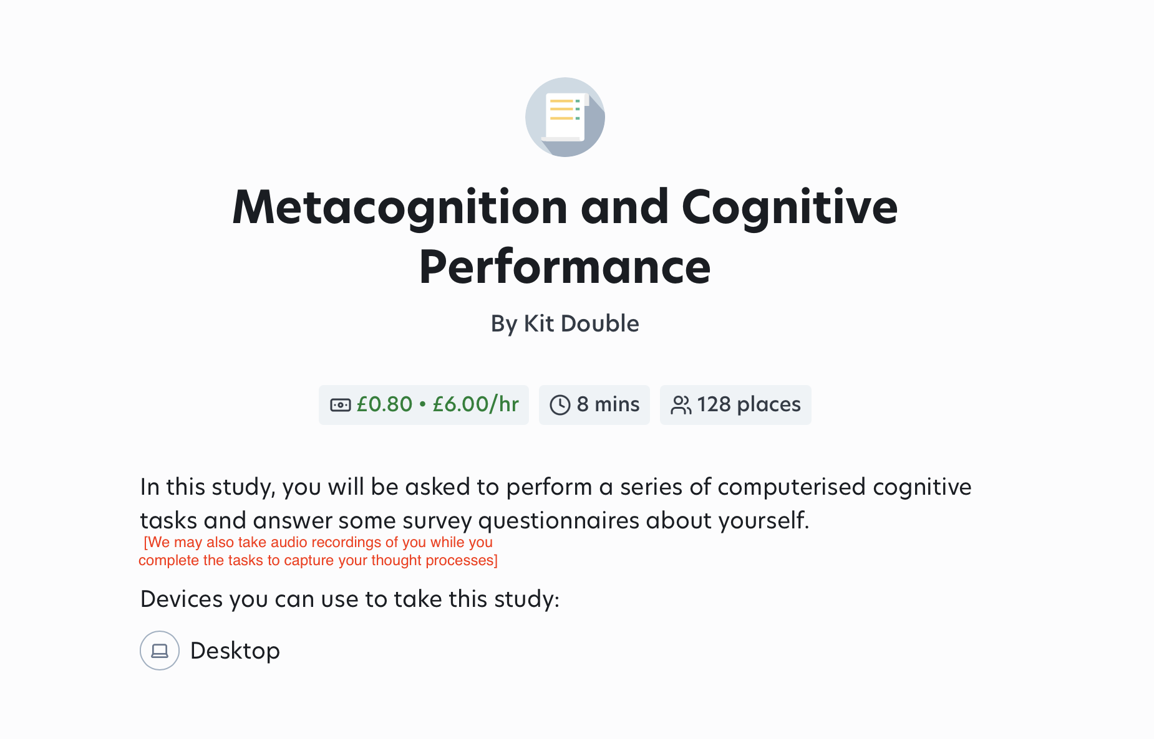

*time and pay will vary, but will always be at a rate of 6 pounds per hour

SONA PAID ADVERTISEMENT

STUDY NAME: Metacognition and Cognitive Performance
RESEARCHERS: Dr Kit Double
ETHICS APPROVAL NUMBER:
BRIEF ABSTRACT: In this study, you will be asked to perform a series of computerised cognitive tasks and answer some survey questionnaires about yourself
DETAILED DESCRIPTION OF STUDY: Participants will be asked to attempt a series of computerised cognitive tasks. These tasks will measure your cognitive abilities under different conditions. You will also answer some survey questions about yourself. [We may also take audio recordings of you while you complete the tasks to capture your thought processes]

You will be compensated for your time at a rate of $10/hr.
This study has received ethics approval from the Human
Research Ethics Committee (Project No. xxxxx)

Social Media Advertisement
Volunteers Needed for Metacognition Study
You are invited to participate in a study on metacognition and cognitive performance. This XX minute online study involves completing measures of cognitive ability and answering some questionnaires about yourself.
You must be over 18 and able complete the study online.
To participate, go to [URL link to Participant Information Statement and study] for more information. [We may also take audio recordings of you while you complete the tasks to capture your thought processes]

Past Participants Email

Volunteers Needed for Metacognition Research Study

You are receiving this email because you previously indicated that you would be interested in participating in more research run by the University of Sydney. We are running a new study where participants will complete a number of cognitive tasks and surveys. Participants must be proficient in English in order to participate in the study. The study will be completed online and take approximately XX minutes. [We may also take audio recordings of you while you complete the tasks to capture your thought processes]

If you would like to participate go to the following link

[LINK to PIS and Study]

Yours sincerely,

Dr Kit Double (Responsible Researcher)
School of Psychology, Faculty of Science
Phone: +61 2 8627 8636 | Email: kit.double@sydney.edu.au
Project number: [xxxxx]

